06 Shrimp Ceviche Martini Salad – Walkin’ With Your Barefeet On

Seafood is a summer favorite in my home, and there is nothing more refreshing than a chilled shrimp ceviche.

“Ceviche” actually calls for raw shrimp to be cooked in the acid of lime juice, but some of your friends may be a little queasy about raw seafood, so, if need be, you can drop the shrimp in boiling water for a couple of minutes until they are barely cooked - the lime juice will finish the job!

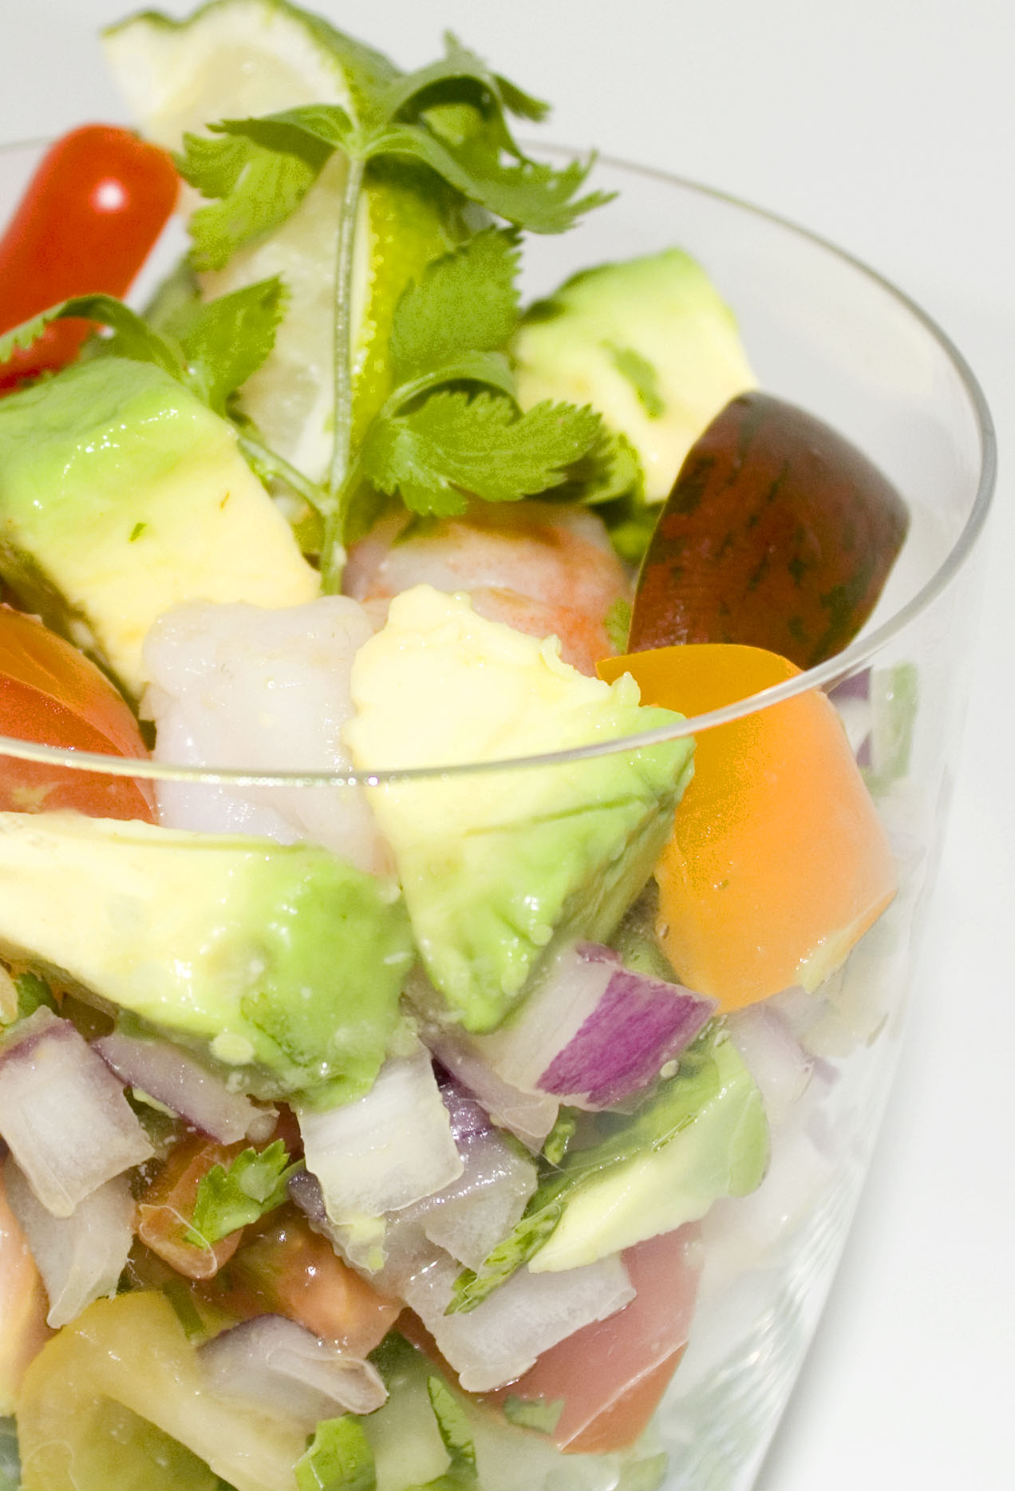
The first time I tried this dish, I was visiting my producer Jesse Frederick in LA and as was our custom, we dined at an amazing little Mexican restaurant while solving the problems of the world. I have very fond memories of those special meetings, the secrets and dreams shared by two close friends over extraordinary cuisine. More recently, Tony and I were dining at Alma de Cuba in Philly – ceviche, of course – when we first learned that we were to be grandparents.

So, ceviche has been there for some major milestones in my life! My version has evolved over the years, but the combo of shrimp, lime, avocado and onion – with a little Serrano heat – is something I still find irresistible. This is a very easy recipe – just take it one step at a time. Here’s to you, Jesse!

Ingredients:

1 lb large raw shrimp
½ medium red onion – medium chop
2 tbsp olive oil
The juice of three limes
1 whole lime for garnish
Cilantro for garnish
1 tsp Sizzle & Swing Chili, Lime & Cilantro Sea Salt
24 grape tomatoes – halved
1/2 small Serrano or jalapeno pepper (optional) minced, seeds removed.
1 medium avocado - cubed
1 1/2 c. shredded lettuce leaves –iceberg is best, or romaine

In a small bowl, combine lime juice, chopped onion, olive oil and let rest for 15 minutes.

Bring 2 quarts of water to a rapid boil, add shrimp, return to a boil and cook for only 1 minute. Immediately rinse in cold water and place in refrigerator for 10 minutes. Peel and de-vein shrimp. Chop shrimp into ½” pieces. Place the prepared shrimp into the lime/onion mixture in the refrigerator for 30 minutes to “cook.” Gently toss after 15 minutes.

Finally, in a larger bowl combine the shrimp mixture with the chopped avocado, tomato, and Serrano or Jalapeno pepper. Mix gently, add Sizzle and Swing seasoning salt and mix again. Adjust salt and pepper to taste. Place in refrigerator for 15 minutes – no more. Toss once more gently.

Line bottom of 8 martini glasses with shredded lettuce. Fill with equal portions of the salad and garnish with a wedge of lime and sprig of cilantro.

Another option – serve the salad wrapped in whole lettuce leaves like a little taco.

Serves 8 as a first course.

