Lemon Pepper Pappardelle
“Looks like you could be liking it, too!”

This delicious pasta can be whipped up in 10 minutes or less. After a long day when I’m coming home late – all charged up, but tired and hungry after a gig – it’s the perfect wind-down meal. Delicious served with a plain green salad. Wash it down with an icy cold chardonnay and enjoy the after-glow!
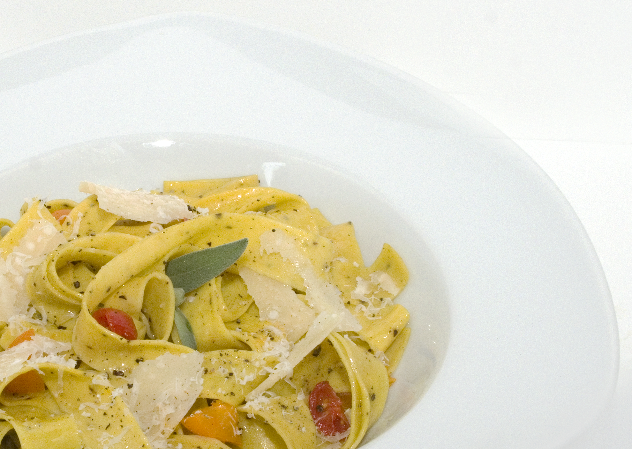
My favorite Italian restaurant back in the day was Da Silvano in New York’s Greenwich Village. Silvano is still at the top of his game and his restaurant continues to attract many famous artists, musicians and actors with its casual warmth and legendary cuisine. From Silvano I learned that the simplest dishes can be the most challenging to perfect – and often the most rewarding.

Serves 3-4

8 oz Pappardelle or Fettuccine noodles
2 garlic cloves minced
½ tsp minced lemon zest (scant) or 1 tsp lemon juice
2 tbsp unsalted butter
1 tbsp olive oil
2 fresh sage leaves – chopped
1 tsp Sizzle & Swing Tuscan Seasoning
1 medium ripe tomato – seeded and diced
3/4 c. shredded parmesan cheese
Salt & Pepper to taste
Optional: Red Pepper Flakes

In medium stockpot, bring 3 quarts of salted water to heavy rolling boil. Add pasta bring to a boil and lower heat to medium. Cook for 6-8 minutes – al dente. Drain the pasta.

Meanwhile melt the butter in a saucepan and add tomatoes, garlic, lemon zest, Sizzle & Swing Tuscan Seasoning and sage. Simmer gently until the garlic is lightly browned and tomatoes are soft, about 2-3 minutes. Stir in the pasta and season with salt and plenty of black pepper. Serve immediately and top with grated Parmesan cheese (red pepper flakes if desired.)

