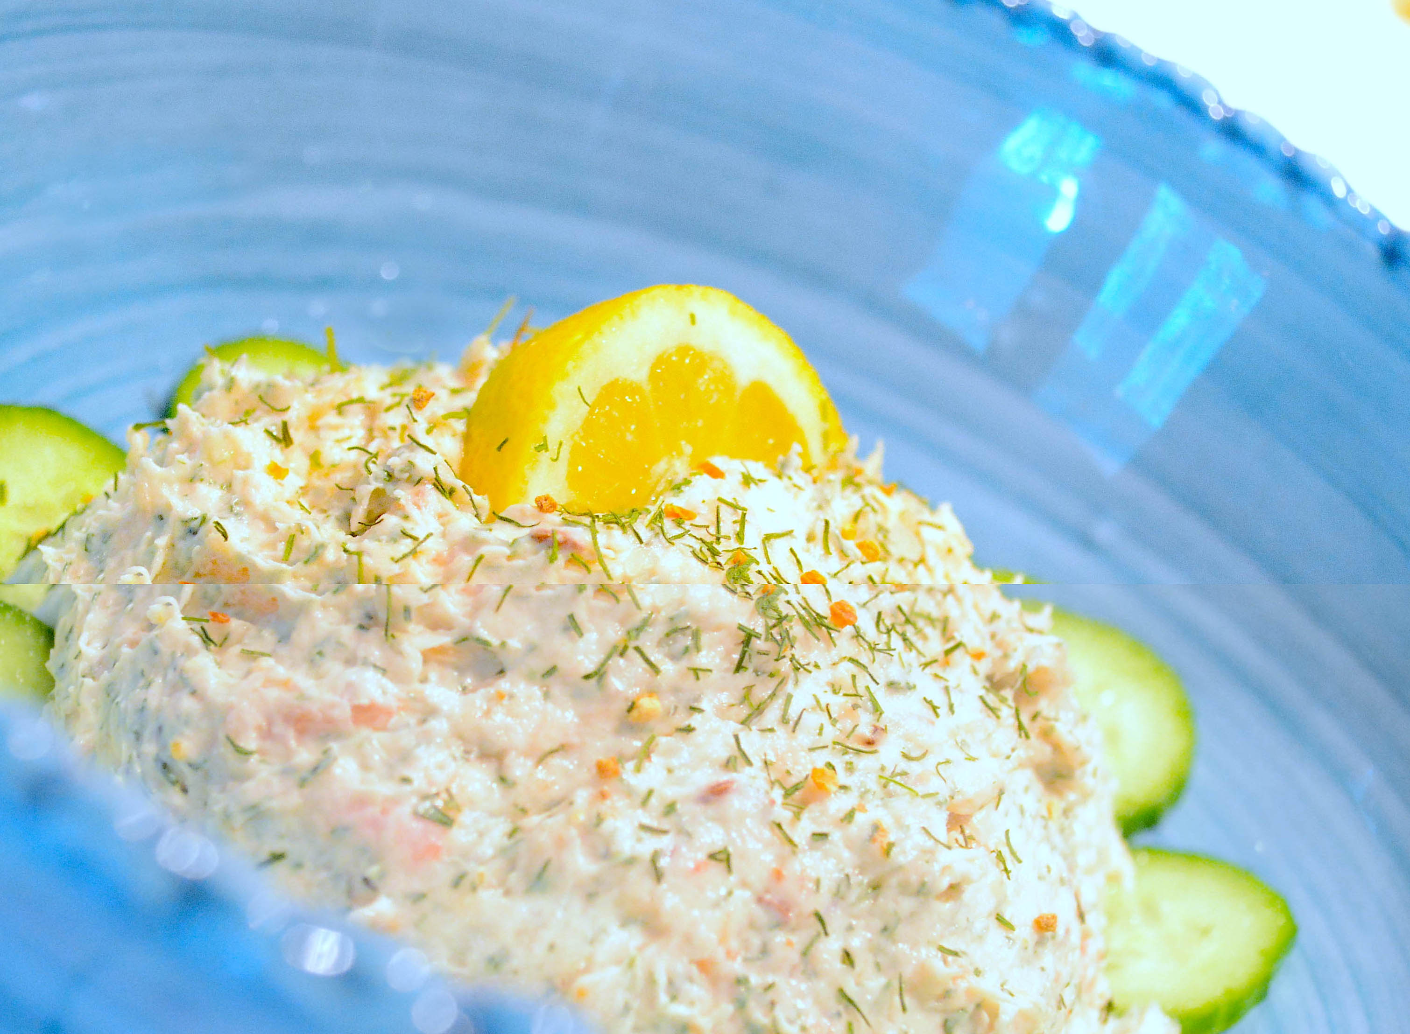
Salmon Mousse

4 oz smoked salmon chopped
4 oz whipped cream cheese
Juice of ½ lemon
2 tsp Sizzle & Swing Tangerine Dill*
½ tsp caraway seeds
Pepper to taste
Cucumbers for garnish

Break up salmon in a large bowl using a fork. Combine remaining ingredients, mashing together with fork or immersion blender. Form into a ball and plate. Chill for 30 minutes and serve with a cucumber or lemon garnish and rye crackers.
* Alternate – substitute 2 tsp dill, 1 tsp lemon zest and salt to taste.

www.SizzleandSwing.com

